JMR Automation Tire Wash Tub - Owner's Manual

PRODUCT OVERVIEW
The JMR Automation Cordless Tire Wash Tub is a mobile, efficient solution for cleaning dirt modified tires. Powered by a Milwaukee M18 or DeWalt 20V battery, it's ideal for both at-the-track and shop use.

FEATURES
- Cordless operation with Milwaukee M18 or DeWalt 20V battery (not included)
- Simple On/Off switch that illuminates when active
- 6.5-gallon water reservoir with overflow control
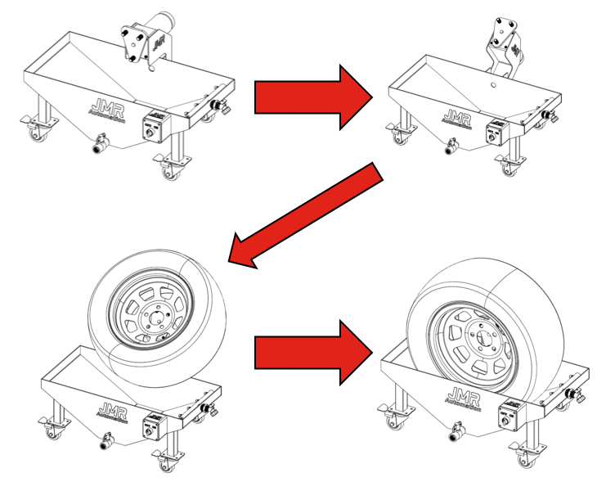
- Built-in stainless-steel brush continuously cleans rotating tire
- Nozzle manifold for optional garden hose spray
- Drain valve for easy emptying and flushing
- Heavy-duty casters for full mobility

QUICK START INSTRUCTIONS
- Fill tub up to the drain hole with clean water.
- Install battery into click on switch box.
- Tilt the motor assembly back.
- Install tire on hub and loosely spin on lug nuts.
- Tilt the motor and tire assembly into tub.
- Turn the switch “ON” to start rotation and cleaning.

NOTE: You may connect a garden hose to the nozzle
manifold for more efficient cleaning.

You may also use the supplied brush to help
Clean the side walls, rim and tread of tire.

- Turn the switch to “OFF” when tire is sufficiently cleaned.
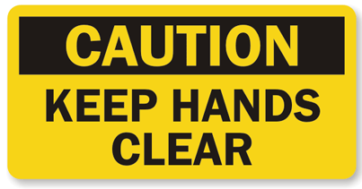
- Remove the tire from the system in the opposite order.
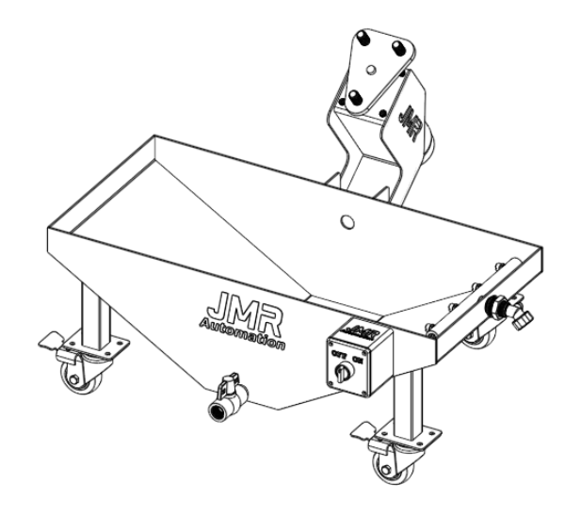
- After cleaning tires, open the front valve to drain water.
- Flush tub with clean water if needed and close valve.

CLEANING & MAINTENANCE
- Drain after every use.
- Use only soap and low-pressure water for cleaning.
- Use garden hose for thorough flushing.
- Store in a dry environment.
- Inspect brushes and drain regularly for debris.

SAFETY NOTES
- Use only Milwaukee M18 or DeWalt 20V batteries.
- Do not operate with loose or damaged parts.
- Keep away from children and pets.
- Do not put hands between the tire and tub sides.
- Do not use with pressure washing systems.

